INF 191B - Social Event 1

The Luminaries: Adam Yee, Antonio Montalvo, Byung Kim, Damon Wong, Ryan Enshaie

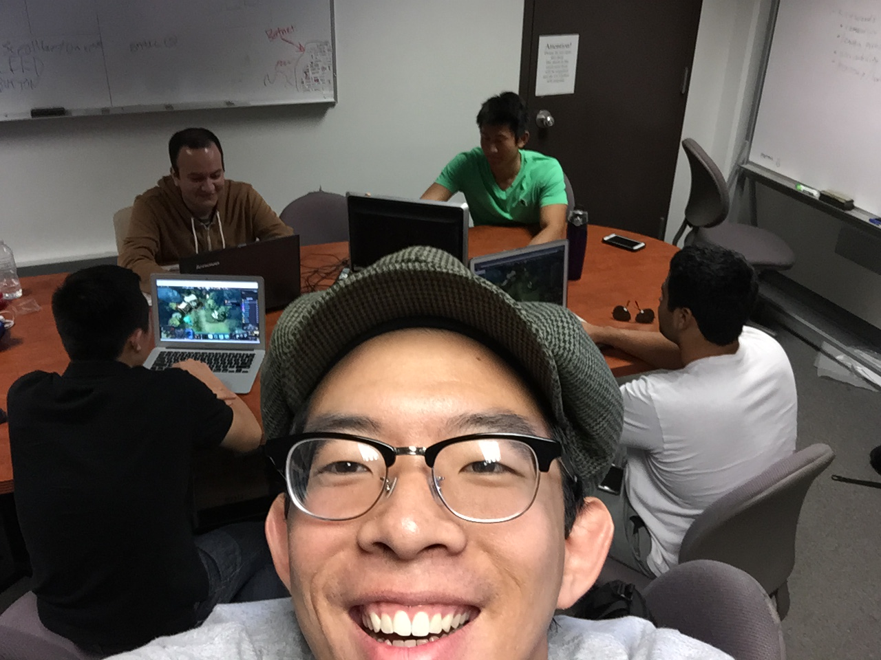

For our social event, we decided to play some video games together. We played games from Dota to League of Legends. It was a good time and way to build up our sense of chemistry as a team in a different type of way. These past weeks have been pretty hectic for some of us, so it was a good time to relieve some of the stress and decompress a bit.